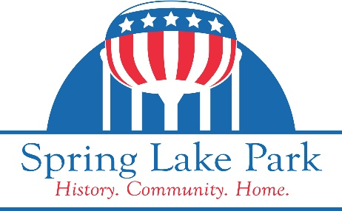
Planning Commission Agenda
Monday, April 22, 2024
Able Park Building, 8200 Able Street NE at 7:00 PM

1. CALL TO ORDER

2. ROLL CALL

3. PLEDGE OF ALLEGIANCE

4. APPROVAL OF MINUTES
A. Approval of Minutes - March 25, 2024

5. APPROVAL OF MINUTES
A. Public Hearing - Variance Application - 738 Sanburnol Drive
B. Public Hearing - Variance - MinnSprouts, LLC - 7705/7707 Central Ave NE

6. OTHER

7. ADJOURN

CITY OF SPRING LAKE PARK RULES
FOR PUBLIC HEARINGS

Public hearings are formal proceedings giving citizens an opportunity to express their concerns on a specific issue. Some issues on which the Planning Commission is required to hold public hearings include subdivisions, zoning changes, conditional use permits, and ordinance amendments.
The following format will be used to conduct a public hearing:
- Planning Commission Chair opens the hearing.

- City staff describes the proposal.
- The applicant has an opportunity to further explain the proposal and respond to questions/ comments on the proposal from the Planning Commissioners.

- Citizens will then have the opportunity to ask questions and/or comment on the proposed project.

  - Those wishing to comment are asked to limit their comments to 3 minutes
  - A group of residents wishing to have their collective opinions voiced may elect a spokesperson to represent them. The spokesperson may have a maximum of 10 minutes to express the views of the group.
  - People wishing to comment are asked to keep their comments succinct and specific.

- After everyone wishing to address the subject of the hearing has done so, the Planning Commission Chair will close the hearing.

- Planning Commissioners will have an additional opportunity to comment and ask questions on the issue.

- The Planning Commission will make a formal recommendation on the issue to the City Council or defer decision pending additional information.

